|  |  |
| --- | --- |
| **Nastavni predmet:** | **MIKROUPRAVLJAČI** |
| **Vježba br.12.:** | **Senzor nagiba (Tilt Sensor)** |
| **Cilj vježbe**: | **Izvesti spoj senzora nagiba sa LED diodama koristeći Arduino** |

**Električna shema senzora nagiba:**

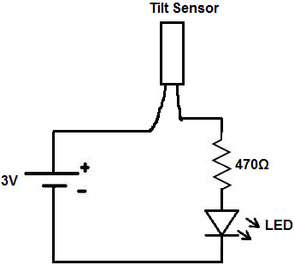

**Zadatak 1:**Spoji senzor nagiba prema zadanoj shemi i pokreni ga korsiteći kod u Arduinu.

**Shema:**

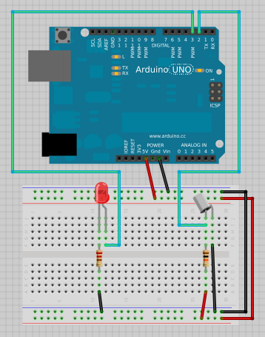

**Kod:**

//Tilt sensor testing

 //Set the pin numbers of the LED and Tilt Sensor

 int inPin = 2;

 int outPin = 4;

//Set up variables

 int LEDState = HIGH;

 int reading;

 int previous = LOW;

//set some debounce values 50 seems a random number I'm not sure either but it works and that's from adafruits tutorial

 long time = 0;

 long debounce =50;

//very important function this just gets run once

 void setup()

 {

 pinMode(inPin,INPUT);

 digitalWrite(inPin,HIGH);

 pinMode(outPin,OUTPUT);

 }

//as the name suggests this is what runs over and over again so its important anything that changes constantly goes in here

 void loop()

 {

 int switchState;

 reading=digitalRead(inPin);

 if(reading != previous)

 {

 time=millis();

 }

 if((millis() - time) > debounce)

 {

 switchState=reading;

if(switchState==HIGH)

 LEDState=LOW;

 else

 LEDState=HIGH;

 }

 digitalWrite(outPin,LEDState);

 previous=reading;

 }

**Zadatak 2:**Spoji 8X8 matricu prema shemi iz zadatka 1 (bez potenciometara) napiši program koji će nasumično paliti jednu točku na matrici.

**Kod zadatka:**

const int col[8] = { 2, 7, 19, 5, 13, 18, 12, 16};

const int row[8] = { 6, 11, 10, 3, 17, 4, 8, 9};

int x,y;

int i;

void setup() {

for ( int thisPin=0; thisPin<8; thisPin++) {

pinMode(col[thisPin], OUTPUT);

pinMode(row[thisPin], OUTPUT);

}

for(i=0;i<8;i++)

digitalWrite(row[i], HIGH);

}

void loop() {

for( i=0; i<8; i++){

digitalWrite(row[i], LOW);

digitalWrite(col[i], HIGH);

}

x=random(8);

y=random(8);

digitalWrite(col[x], LOW);

digitalWrite(row[y], HIGH);

delay(200);

}

**Zadatak 3:**Spoji 8X8 matricu prema shemi iz zadatka 1 (bez jednog potenciometra) i napiši program kojim će se moći mijenjati brzina kojom se nasumično prikazuje točka pomoću potenciometra.

**Kod zadatka:**

const int col[8] = { 2, 7, 19, 5, 13, 18, 12, 16};

const int row[8] = { 6, 11, 10, 3, 17, 4, 8, 9};

int x,y;

int i,r;

void setup() {

for ( int thisPin=0; thisPin<8; thisPin++) {

pinMode(col[thisPin], OUTPUT);

pinMode(row[thisPin], OUTPUT);

}

for(i=0;i<8;i++)

digitalWrite(row[i], HIGH);

}

void loop() {

r=map(analogRead(A0), 0, 1023, 0, 1000);

for( i=0; i<8; i++){

digitalWrite(row[i], LOW);

digitalWrite(col[i], HIGH);

}

x=random(8);

y=random(8);

digitalWrite(col[x], LOW);

digitalWrite(row[y], HIGH);

delay(r);

}